**Saving App**

**System Design**

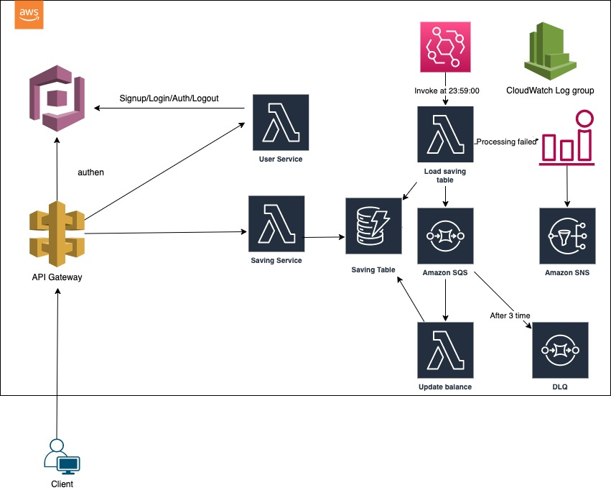

I will design this saving app base on AWS serverless lambda framework for easy scaling and Infrastructure of Infrastructure managed.

About authentication/user service, I will use AWS Cognito. System will have lambda function for user to register/login/logout and it will call to AWS Cognito to managed the user and do authenticate.

About Saving service, I will use lambda function with DynamoDB, as the database design I will use SQL (because of the requirement need to scaling up to 1M user, 10M transaction, I prefer AWS Aurora). But for quick implement the prototype, I use DynamoDB no SQL.

About the job to calculated the interest I will use AWS EventBridge trigger a lambda function to get all saving account and push to SQS queue, and another lambda functions to pull these account to calculate and updated. For prototype I use lambda function, but for product, I will use the EC2 schedule start to run long running task (because of the limit of lambda function is 15 minutes, so when database is bigger task will take more time, and don’t known how long it will finish) .

Because readthrough of database is higher than writethrough, so I will use a SQS queue and many lambda function to subscribe to it and process until finished.

If the processing failed, it will trigger cloudwatch alarm and send event to SNS for other processing (SMS, email, …)